TRAIN RESERVATION SYSTEM USING MEAN STACK (CRUD OPERATION)

In this Application I have used MEAN (MongoDb, Express.Js, Angular.Js ,Node.js) for implementation.

In train Reservation system for crud operation I just booked Train ticket, cancel ticket, search for booked tickets, view train details, view my ticket, delete ticket.

For booking ticket we can see if seat is available for given constraints(time, date, destination city, from city),if seat is available it will redirect to seat booking page where we enter personal details for a passenger like name, age, address, EmaiId ,phone number then confirms the booking. After confirming the booking it displays the ticket Id which we can use for ticket search.

In main Menu we can 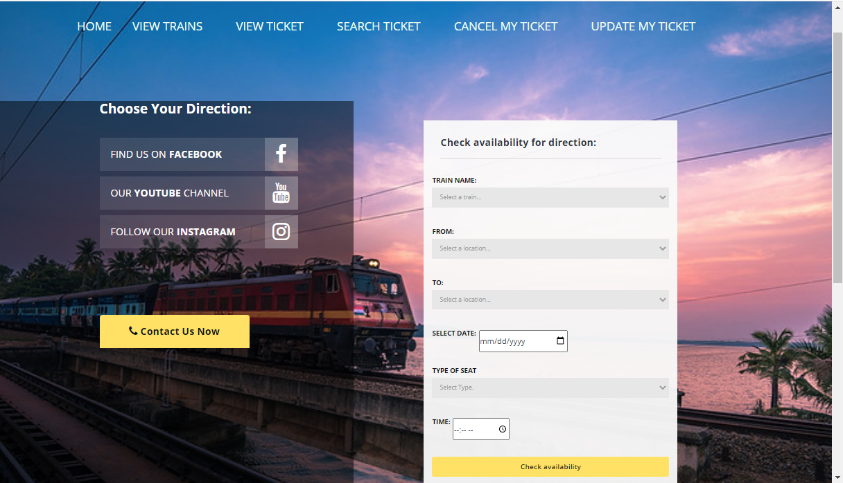

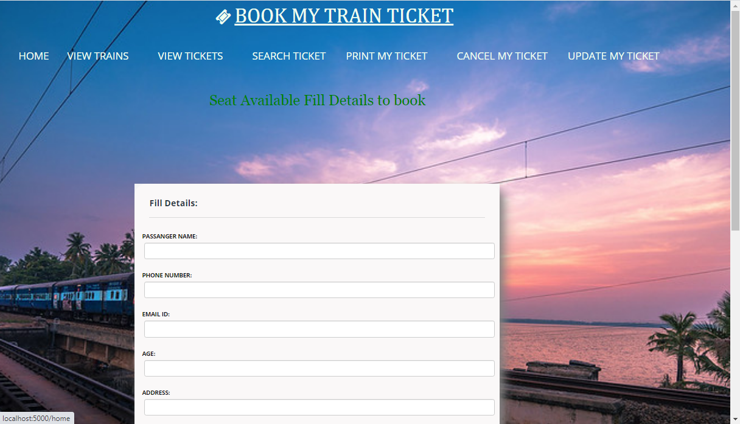

**Search ticket**-with ticket id it displays ticket details with passenger details,

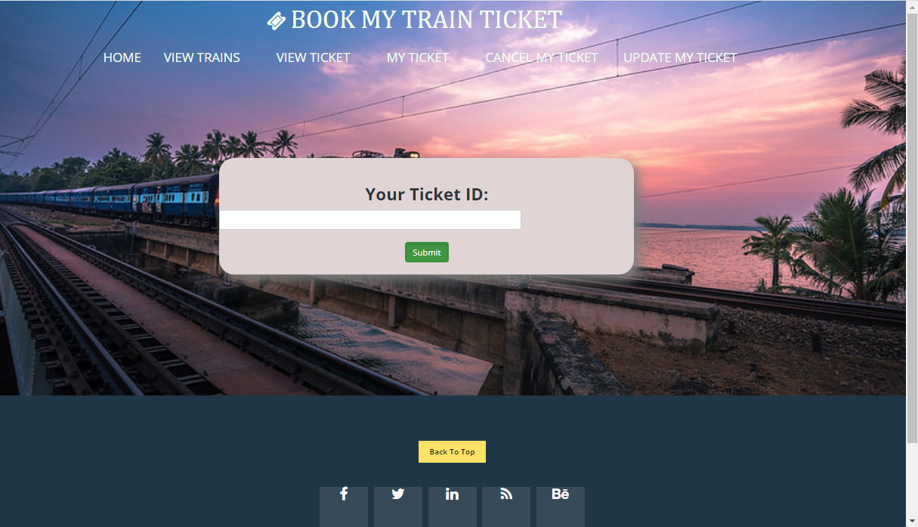

**View train Details**-displays train details like destination city, from city, time of departure.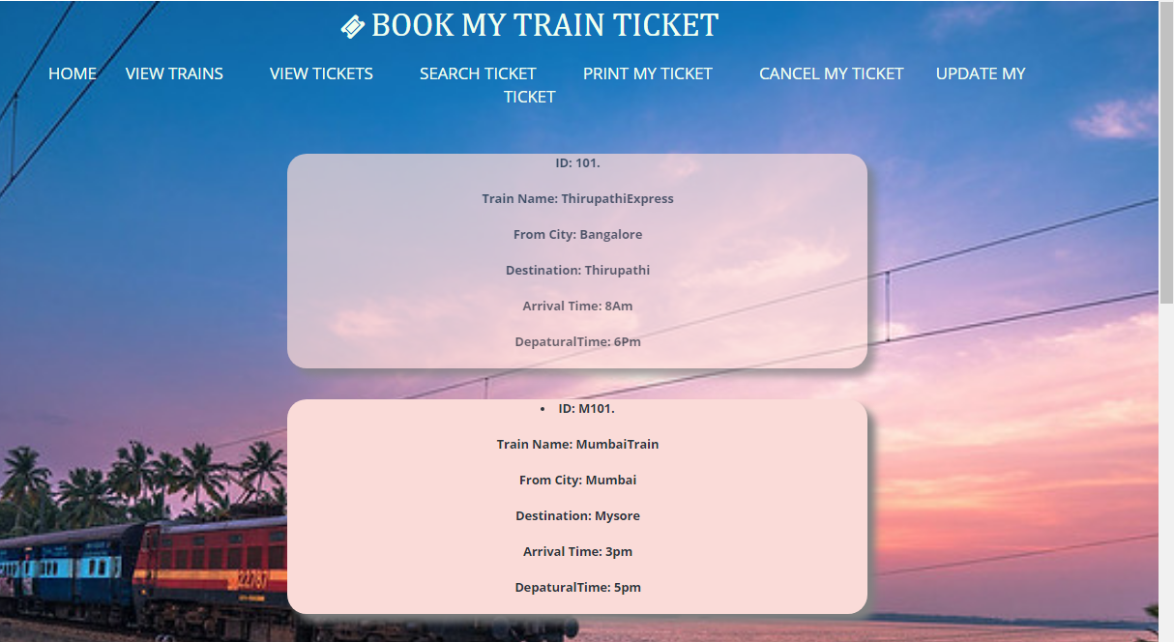

**View ticket**-displays booked ticket details provided ticket id.

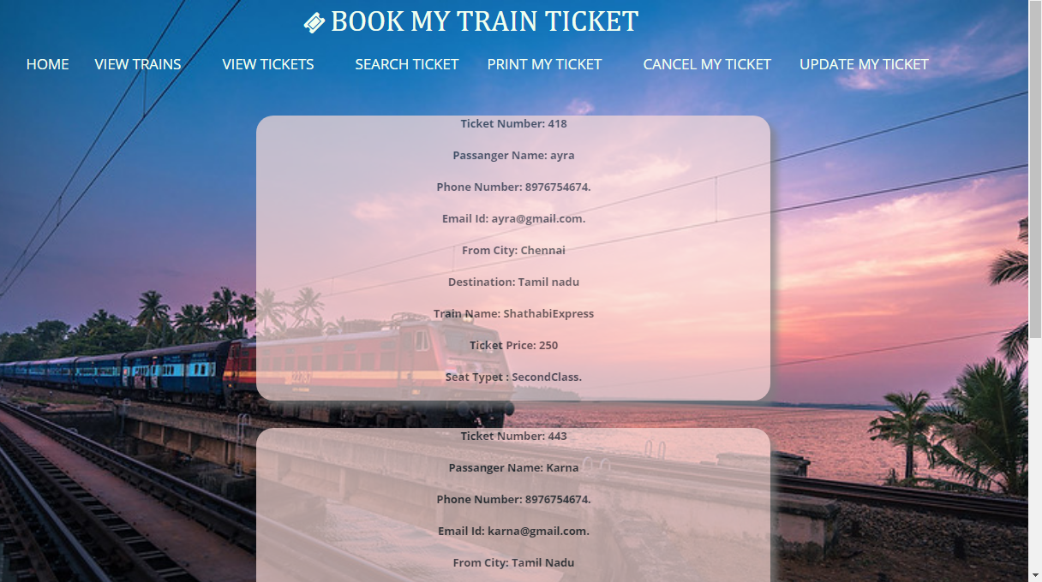

**Cancel ticket**-deletes ticket from database with provided ticket id.

**Update ticket**-update ticket details with provided ticket id and other details.



Prerequisite Installation:

1.Install MongoDB server.

2.Visual studio Code Editor(optional any other code editor can be used).

3.Install Angular.Js

Steps to run:

1.Download the zip file.

2.Extract it

3.Start the MongoDb server.

4.Open Command prompt where you have extracted project

5.Execute command ”node route_angmongo.js”.

6.Then open browser type <https://localhost:5000>.